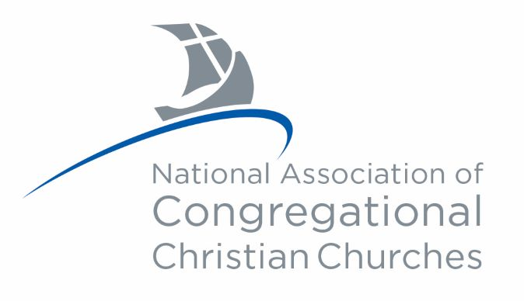
In 2022, we introduced people, practices, and possibilities into the life of the National Association and our member churches.
The Executive Director convened a Planning and Action Committee comprised of representatives of boards and councils. This team delivered objectives to cultivate continuity and cohesiveness among myriad organizational initiatives.
Supporting those who occupy pastoral leadership positions: The inaugural cohort of the Lay Ministry Training Program completed their first year of coursework while the second cohort began their studies. Partnering with the Interim Ministry Network, the Vitality Ministry Council sponsored a training for clergy. Forty-four pastoral leaders attended three in-person Ministers Convocations in Connecticut, Michigan, and Nevada.
The staff developed specialized social media to better respond to inquiries and foster connections among churches. Members of NACCC churches can exchange ideas by logging on to the Members Forum, a new feature on the website.
The Mission and Ministry Outreach Council completed a review of mission partners that will help local churches and individuals engaged in mission activity in new and meaningful ways. MOMC raised over $70,000 to support Ukraine, in addition to receiving other substantial collections for natural disaster relief in the US.
Over 150 people attended our first hybrid annual meeting and conference, hosted by two churches in Wichita, Kansas. At that gathering, we welcomed six new member churches into the NACCC. Two more congregations were approved as provisional members during the second half of the year.
On July 1, the Executive Director embarked on a Listening Tour endeavoring to visit all 313 member churches. As of December 2022, she has completed stops at 28 churches in ten states. In addition, Rev. Cleere spoke at three state/regional association meetings and participated in an ordination. She preached at three churches on Sunday morning and also at an installation.
We are grateful for the countless hours committed Congregationalists contributed to these and other accomplishments.

